Singapore Institute of Technology - University of Glasgow  
Joint Degree in Computing Science Degree Programme

CSC3101 Capstone Project

Please complete the following form and attach it to the Capstone Report submitted.

**Capstone Period:**   **<DD MMM YYYY> to <DD MMM YYYY>**

**Assessment Trimester: Final Trimester**

**Project Type: Industry**

**Work Supervisor Details & Declaration:**

Name: <Work Supervisor’s Full Name>

Designation: < Work Supervisor’s Organisation Designation>

Department: < Work Supervisor’s Organisation Department>

Email Address: < Work Supervisor’s Email Address>

Contact Number: < Work Supervisor’s Contact Number>

**Academic Supervisor Details:**

Name: <Academic Supervisor’s Full Name>

Designation: <Academic Supervisor’s Designation>

Email Address: <Academic Supervisor’s Email Address>

Contact Number: <Academic Supervisor’s Contact Number>

**Student Particulars & Declaration:**

Name of Student: <Student’s Full Name>

Student ID: <Candidate’s Student ID>

I hereby acknowledge that I have engaged and discussed with my **Academic Supervisor** and **Work** **Supervisor** on the contents of this Final Capstone Report and have sought approval to release the report to the Singapore Institute of Technology and the University of Glasgow.

|  |  |
| --- | --- |
|  |  |
| **Date:** <DD MMM YYYY> | |

**END OF FORM**

|  |
| --- |
| A picture containing graphical user interface  Description automatically generated  Singapore Institute of Technology - University of Glasgow Joint Degree in Computing Science Degree Programme |
| Final Capstone Report  “Title of Capstone Project”  For **Final Trimester** from <DD MMM YYY> to <DD MMM YYYY>  *<Student’s Name>*  *Student ID: <Student’s Student ID>* |
| Academic Supervisor: *<Academic Supervisor’s Full Name>* |
| Submitted as part of the requirement for CSC3101 Capstone Project |

Table of Contents

List of Figures 2

List of Tables 2

Acknowledgments 3

1. Introduction 4

1.1. Problem Formulation 4

1.2. Project Objectives/Project Specifications 4

2. Literature Review 5

3. Methodology / Proposed Design 6

4. Results and Analysis 7

5. Project Management 8

6. Conclusion 9

7. References 10

8. Knowledge and Training Requirements 11

8.1. Applicable Knowledge from the Degree Programme 11

8.2. Additional Knowledge, Skillsets, or Certifications Required 11

Appendices 12

Appendix A: FORMATTING AND STYLISTIC CONSIDERATIONS 12

List of Figures

Figure 1: SEM image of a particulate composite.

List of Tables

Table 1: Predicted Student Grade Distribution

Acknowledgments

Acknowledgments may be made to individuals or institutions not mentioned elsewhere in the report who have made an important contribution. The folowing is an example for how an acknowledgement could be written.

This project would not have been possible without the support of many people. I would like to thank my academic supervisor, Professor Xavier, for his guidance, patience, encouragement, and committed assistance during my capstone project. I would also like to thank my John Doe for his constructive recommendations during the preliminary stages of this project. I also wish to thank Ali, Raju, and Meng Cheng for their technical assistance with coffee analysis and modeling.

1. Introduction

The introduction sets out what you plan to say and summarises the problem under discussion and its motivation. It serves as an opening for the main body of the final capstone report. You should include information about the background of your research and what its aims, motivations and objectives. Do state any limitations within the scope of the research.

This chapter should mainly come from the Start Trimester Capstone Report, if the project have remained the same.

* 1. Problem Formulation

State the problem to be solved as indicated by the need (Academic supervisor, work supervisor, or self proposed). Present the objectives and expectations of the need and constraints given to the problem. You should also include some literature in this section, reporting what is already known about your question/topic and any gaps.

Show that the problem has been formulated by presenting appropriate design methods Objective taking into consideration the following factors:

* List two to three sub-problems and elaborate on them (one paragraph for each sub-problem).
* Justify that these problems are worth working on and have not been solved
* Cite any initial past relevant literature work (IEEE, ACM etc.)
  1. Project Objectives/Project Specifications

Project objectives are what you plan to achieve by the end of your project. This includes deliverables and assets, or more intangible objectives like increasing system performance. Your project objectives should be attainable, time-bound, specific goals you can measure at the end of your project.

Give a clear set of design specifications for the project. The design specifications should be clear concise statements with a specific metric and an appropriate value. The specifications should provide an unambiguous measure of the success of the final design in meeting the need and constraints associated with the design problem.

1. Literature Review

The primary purpose of this section is to summarise the general findings of the literature review (what do most of the resources conclude) and comment on the availability of resources in the subject area. A good practice would be to start with a concise definition of the selected topic and the scope of the related literature being investigated. It should also mention intended exclusions.

Find the relevant literature in your research area. This is followed by logging, organising and synthesising the work. There are many ways to organise the assessment of the work, i.e. chronological (by date/period) and thematic (into themes) approaches. Depending on what approach you take, separate each topic to its own sub-section, e.g. 2.1, 2.2, etc.

If your project is **research-based**, we expect you to do a review of the existing research works already published and identify the gap in the exiting works. If your project is **software-development-based**, we expect you to list and discuss the requirements for the software to be developed. In addition, you are required to review the existing solutions in literature and present what are their limitations.

**Each work** should be critically **summarised** and **evaluated** for its hypothesis, methodology, and conclusion. It is vital to address inaccuracies, omissions, and errors, as it is to identify accuracy and relevance to **your problem statement**.

The **final sub-section** summarises the key findings of the literature review. Similarities between works could be highlighted here. A reasonable conclusion would also justify the research proposal. Therefore, the idea should be re-stated and supported according to the review's findings.

Show that a judicial decision making process was used to reduce the number of possible conceptual solutions to a single (optimal) solution that is to be implemented and verified and/or validated by the end of the project. Discuss why alternative solutions were rejected/chosen over other solutions. Describe the criteria used to evaluate potential solutions. Substantiate that the proposed final proposed design is the optimal choice in providing the functionality necessary while best meeting the specified constraints of the design problem. Document in detail the decision making process.

This chapter should mainly come from the Middle Trimester Capstone Report, if the project have remained the same.

1. Methodology / Proposed Design

**For Research-based Casptone**: You are expected to name this section as “Methodology”. You must highlight the novelty in the proposed methodology/algorithm that is lacking in existing literature. Also, outline the overall framework and strategy that was used to achieve the objectives. Specifically, you must discuss on the research methods used, the tools or research instruments used and provide a detailed description on how data was collected. A clear explanation on the proposed methodology and algorithm is required.

**For Software-based Capstone:** You are expected to name this section as “Proposed Design”. You must highlight the novelty in the proposed design that is lacking in existing literature. Also, provide a detailed description of the proposed design, including the plan and framework. In addition, provide rationale to support the design choices and how your design addresses the limitations mentioned in Literature Review section. You are expected to explain the design part of SDLC namely user requirement solicitation and analysis, software requirement, design implementation using structured and behavioral modeling but not limited to. You are required to clearly describe the technical contributions if open-source codes are used for the design.

In summary include the following information to support this section:

* Thoroughly present and discuss all engineering analysis used in the design process.
* Each subsystems should be discussed in a new sub-section
* Present all formulations, assumptions and parameters used.
* The discussion must be clear enough for reviewing process as well as repeating the design.
* You should be able to prove that the design will not fail and will perform as required solely through analysis. If you cannot predict it, then it is research, not engineered design.

1. Results and Analysis

The results sub-section should aim to narrate the findings without trying to interpret or evaluate, and also provide a direction to the discussion section of the report. The results are reported and reveals the analysis. The analysis section is where the writer describes what was done with the data found.

**For Research-based Capstone:** You are expected to compare your work with the existing literature. You must discuss and explain how and why the proposed methodology or algorithm has improved the performance analytically.

**For Software-Development-based Capstone:** You are expected to do a full testing of the proposed software against the requirements listed in the literature review section. You also need to conduct a performance evaluation of your solution and compare it to other existing methods in literature. In addition, present how you ensure that the software works against any irregularities. Also, indicate the acceptance level of the proposed software through spectrum of software testing methodology such as code and test coverage analysis but not limited to.

The results sub-section should include the findings of your study and ONLY the findings of your study. The findings include:

* Data presented in tables, charts, graphs, and other figures
* A contextual analysis of this data explaining its meaning in sentence form
* All data that corresponds to the central problem question(s)
* All secondary findings (secondary outcomes, subgroup analyses, etc.)

The analysis sub-section looks at what you do with all the result data you have collected. The analysis of information can be done at a whole range of levels depending on what you want to do with the information. The following are some points that should be include in the analysis sub-section.

* Description of the weak and strong points (based on the data presented)
* Discussion of the effect and impact
* Includes criticism

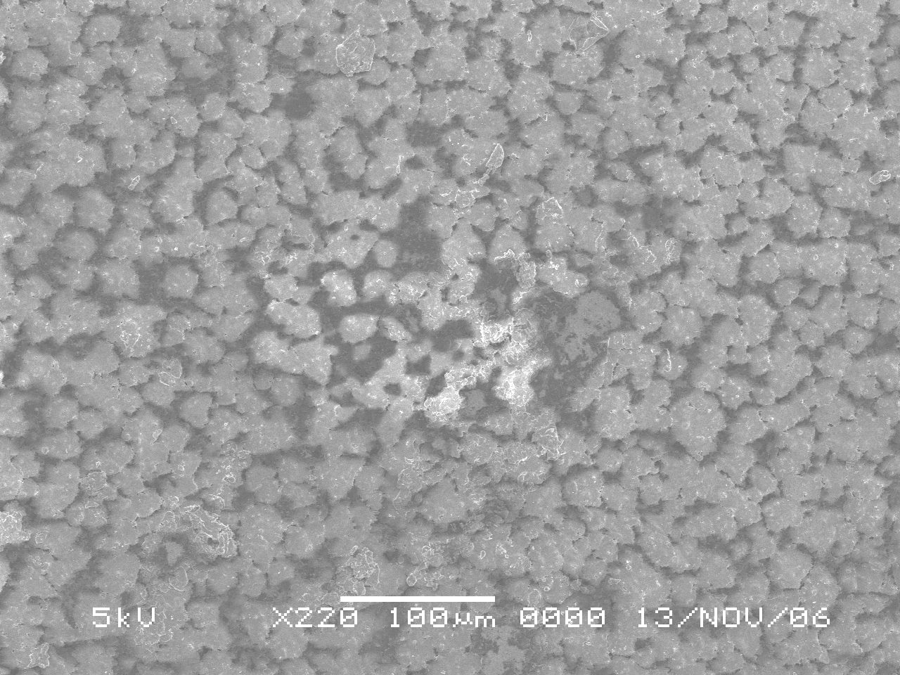

Figure 1: Random Image of a Something.

1. Project Management

In this section, you should provide a detailed overview of how the project was managed from start to finish, including the strategies, skills, tools and techniques that were used to ensure project success. You should outline the project timeline, including milestones, deadlines, and the critical path. This can be done using Gnatt Chart. In addition, discuss in detail the resources that have been used in the project, including personnel, budget, and materials.

Example of a Gnatt Chart:

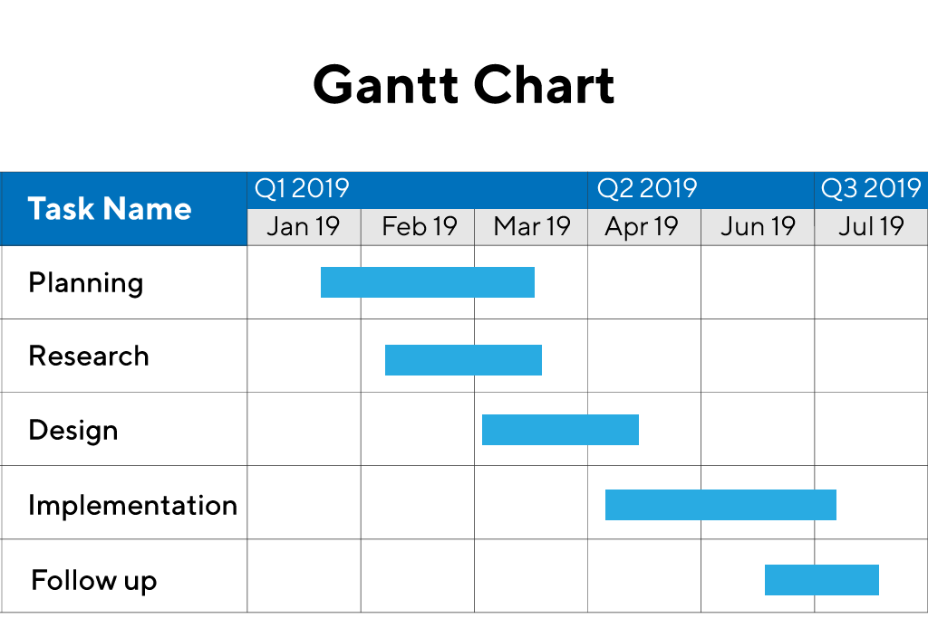

Reference: <https://www.productplan.com/glossary/gantt-chart/>

1. Conclusion

Give a brief and informative summary of all your important results. List what was accomplished and how well the final design functioned and/or met the specifications and needs of the client. Answer how your solution solves the problem defined, as stated in your introduction.

Target a reader who may not have time to read the whole report yet, but needs the results or the conclusions immediately. This is a typical situation in real life. Some readers will read your

introduction and skip to your conclusion first, and read the whole report only later (if at all).

You may also draw perspectives to similar work. Discuss what is missing? In what directions could your work be extended for future work? Give recommendations for improved design.

1. References

The references are a list of any sources you have used in your report. Your report should use the standard referencing style following an established referencing format (e.g., IEEE, Harvard, APA, etc.).

1. Knowledge and Training Requirements

The section list all the knowledge, skillsets and certifications both from the degree programme and beyond that was necessary for the successful completion of the capstone projects.

* 1. Applicable Knowledge from the Degree Programme

The prerequisite knowledge and skillsets from the degree programme that was necessary for the capstone projects are as follows:

|  |  |  |
| --- | --- | --- |
| **No.** | **Module(s)** | **Knowledge(s) Applied** |
| 1 | CSC2003: Embedded System Programming | I did not have much time to deal with embedded systems or hardware during my Capstone project. However, Embedded Systems did give me the knowledge to understand how to utilize multiple threads within a computer when building modules for the Nuclear Launch System. Implementing asynchronous calls facilitates a responsive system as compared to an synchronous one. In addition, my understanding of how how machines on the company facilities communicated with the Launch System through the various protocols for data collection purposes. |
| 2 | CSC2102: Human Computer Interaction | The module teaches us about the basics of creating a better User Interface (UI) and User experience (UX). This is important in a Nuclear Launch System as there are many functions throughout the software. This gives me the awareness to place a button with the right icon at the correct position within the software to give users a fluid experience. |
| 3 |  |  |
| 4 |  |  |
| 5 |  |  |
| 6 |  |  |
| 7 |  |  |
| 8 |  |  |
| … |  |  |

* 1. Additional Knowledge, Skillsets, or Certifications Required

The following are the additional requirements and knowledge that were required for for the capstone projects:

|  |  |  |
| --- | --- | --- |
| **No.** | **Additional Requirement(s)** | **Knowledge(s) Applied** |
| 1 | Computer Hardware Knowledge | Knowledge required to allow performing of comparison of server hardware specifications and knowing what hardware is best suited for department purchase |
| 2 | Offensive Security Certified Professional (OSCP) | Offensive Security knowledge enhance security testing knowledge and concepts which is useful for performing security tests on infrastructure setup, network and web applications |
| 3 | Certified Ethical Hacker (CEH) | Knowledge gathered are on the basic concepts of information security as a whole |
| … |  |  |

Appendices

Include in the appendices information that **could not be included** in the formal body of the report because it would disrupt the continuity of the discussion. Background materials, product catalogs, experimental data tables, and extra documentation should be placed in the appendix.

Appendix A: FORMATTING AND STYLISTIC CONSIDERATIONS

The following are included as suggestions:

* Number the pages (the title page do not have page numbers. The “Introduction” is page 1.)
* Use a clear and logical heading style to identify the main and sub-sections of the report.
* Use an easy to read font (such as Arial, size 11).
* Use 1.5 line spacing and use a consistent amount of white space between sections and subsections.
* Use a 1” (2.54cm) margin on all 4 sides of the page.
* Use figures or tables whenever information is easier to understand in graphical or tabular form.
* Table captions and numbers go above the table.
* Figure captions and numbers go below the figure.
* Introduce tables and figures before they appear.
* All pictures should be digital quality or so they can be laser printed with high clarity in the report. Figures or tables taken from other sources must be properly acknowledged.

**END OF REPORT**